#(1)sklearn linear regression example using diabetes with plot

import numpy as np

import matplotlib.pyplot as plt

from sklearn import datasets, linear_model

from sklearn.metrics import mean_squared_error, r2_score

diabetes = datasets.load_diabetes()

diabetes_X = diabetes.data[:, np.newaxis, 2]

diabetes_X_train = diabetes_X[:-20]

diabetes_X_test = diabetes_X[-20:]

diabetes_y_train = diabetes.target[:-20]

diabetes_y_test = diabetes.target[-20:]

regr = linear_model.LinearRegression()

regr.fit(diabetes_X_train, diabetes_y_train)

diabetes_y_pred = regr.predict(diabetes_X_test)

plt.scatter(diabetes_X_test, diabetes_y_test,  color='black')

plt.plot(diabetes_X_test, diabetes_y_pred, color='blue', linewidth=3)

plt.xlabel('Scaled BMI')

plt.ylabel('Diabetes Progression')

plt.title('Linear Regression Example on Diabetes Dataset')

plt.xticks(())

plt.yticks(())

plt.show()

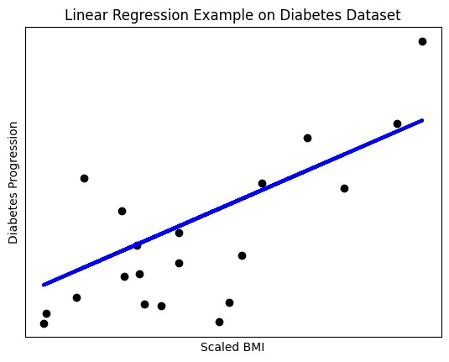

#(2)sklearn linear regression  using iris dataset

import numpy as np

import matplotlib.pyplot as plt

from sklearn import datasets, linear_model

iris = datasets.load_iris()

X = iris.data[:, np.newaxis, 0]

y = iris.target

regr = linear_model.LinearRegression().fit(X, y)

y_pred = regr.predict(X)

plt.scatter(X, y, color='black')

plt.plot(X, y_pred, color='blue', linewidth=3)

plt.xlabel('Sepal Length')

plt.ylabel('Iris Species')

plt.title('Linear Regression on Iris Dataset')

plt.show()

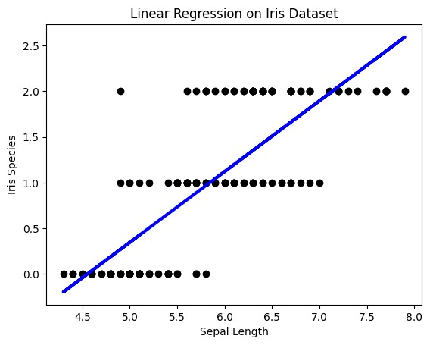

#(3) Python program using Iris dataset before fitting it to a Linear Regression Model with plot

import numpy as np

import matplotlib.pyplot as plt

from sklearn import datasets

iris = datasets.load_iris()

X = iris.data[:, np.newaxis, 0]

y = iris.target

plt.scatter(X, y, color='black')

plt.xlabel('Sepal Length')

plt.ylabel('Iris Species')

plt.title('Iris Dataset - Sepal Length vs Species')

plt.show()

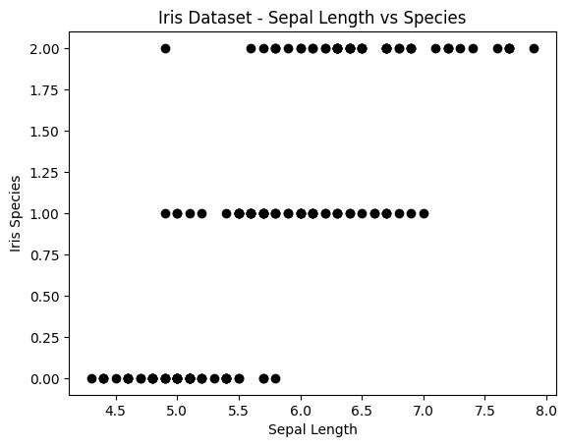

#(6) Python code on sklearn decision tree using breast_cancer with plot.

import matplotlib.pyplot as plt

from sklearn.datasets import load_breast_cancer

from sklearn.tree import DecisionTreeClassifier, plot_tree

from sklearn.model_selection import train_test_split

breast_cancer = load_breast_cancer()

X = breast_cancer.data

y = breast_cancer.target

X_train, X_test, y_train, y_test = train_test_split(X, y, test_size=0.2, random_state=42)

clf = DecisionTreeClassifier(random_state=42)

clf.fit(X_train, y_train)

plt.figure(figsize=(20, 10))

plot_tree(clf, filled=True, feature_names=breast_cancer.feature_names, class_names=breast_cancer.target_names)

plt.title('Decision Tree for Breast Cancer Classification')

plt.show()

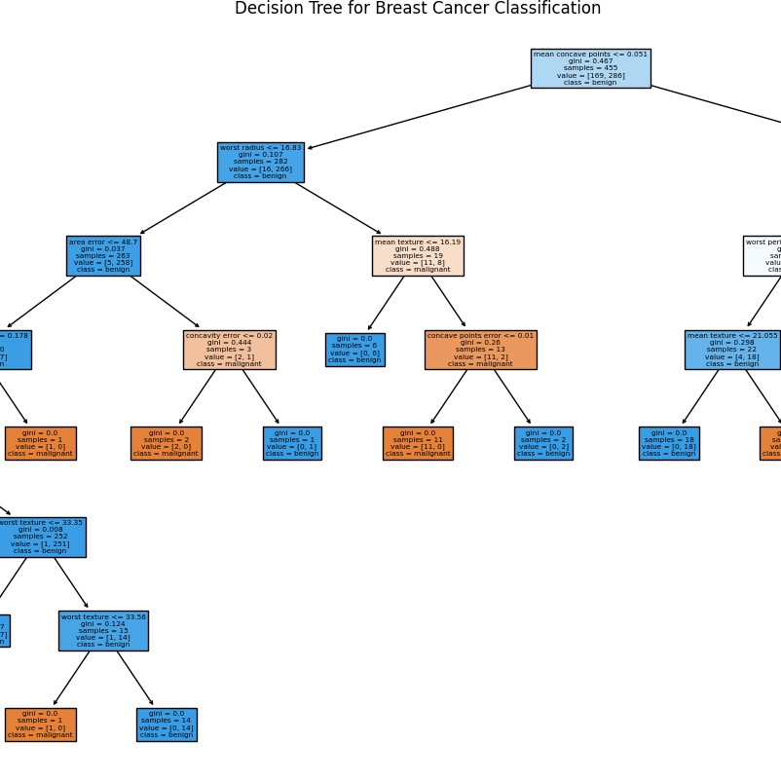

#(7) Python code on sklearn Kmeans classifier using Iris dataset with plot.

import matplotlib.pyplot as plt

from sklearn.datasets import load_iris

from sklearn.cluster import KMeans

iris = load_iris()

X = iris.data[:, :2]

kmeans = KMeans(n_clusters=3, random_state=42)

kmeans.fit(X)

plt.figure(figsize=(8, 6))

plt.scatter(X[:, 0], X[:, 1], c=kmeans.labels_, cmap='viridis', edgecolor='k')

plt.scatter(kmeans.cluster_centers_[:, 0], kmeans.cluster_centers_[:, 1], marker='x', s=300, c='red', label='Centroids')

plt.title('KMeans Clustering on Iris Dataset')

plt.xlabel('Sepal length')

plt.ylabel('Sepal width')

plt.legend()

plt.colorbar(label='Cluster')

plt.show()

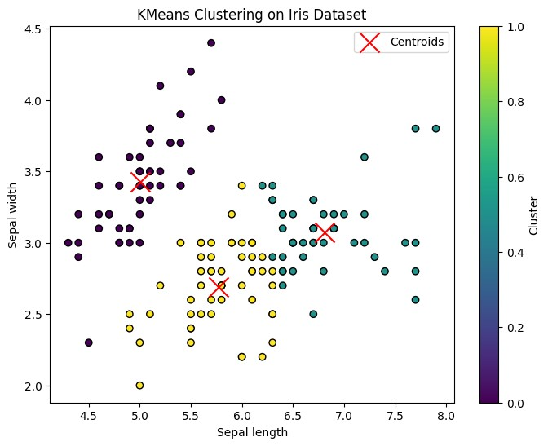

#(8) Python code on sklearn Random Forest using breast_cancer with plot

import numpy as np

import matplotlib.pyplot as plt

from sklearn.datasets import load_breast_cancer

from sklearn.ensemble import RandomForestClassifier

breast_cancer = load_breast_cancer()

X = breast_cancer.data

y = breast_cancer.target

clf = RandomForestClassifier(n_estimators=100, random_state=42)

clf.fit(X, y)

plt.figure(figsize=(10, 6))

plt.barh(range(X.shape[1]), clf.feature_importances_, align='center')

plt.yticks(range(X.shape[1]), breast_cancer.feature_names)

plt.xlabel('Feature Importance')

plt.ylabel('Feature')

plt.title('Random Forest Feature Importances on Breast Cancer Dataset')

plt.show()

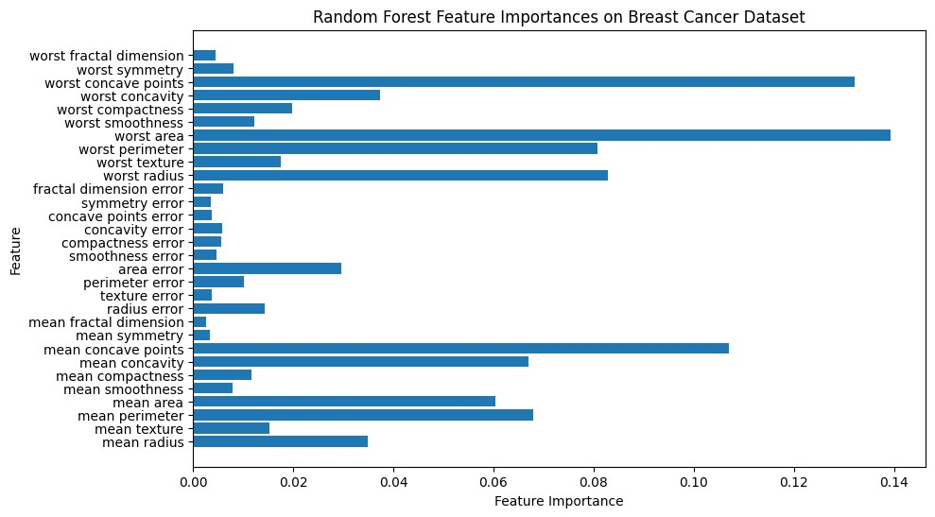

#(9) Python code on sklearn Kmeans classifier using breast_cancer dataset with plot.

import matplotlib.pyplot as plt

from sklearn.datasets import load_breast_cancer

from sklearn.cluster import KMeans

from sklearn.decomposition import PCA

breast_cancer = load_breast_cancer()

X = breast_cancer.data

pca = PCA(n_components=2)

X_pca = pca.fit_transform(X)

kmeans = KMeans(n_clusters=2, random_state=42)

kmeans.fit(X_pca)

plt.figure(figsize=(8, 6))

plt.scatter(X_pca[:, 0], X_pca[:, 1], c=kmeans.labels_, cmap='viridis', edgecolor='k')

plt.scatter(kmeans.cluster_centers_[:, 0], kmeans.cluster_centers_[:, 1], marker='x', s=300, c='red', label='Centroids')

plt.title('KMeans Clustering on Breast Cancer Dataset')

plt.xlabel('Principal Component 1')

plt.ylabel('Principal Component 2')

plt.legend()

plt.colorbar(label='Cluster')

plt.show()

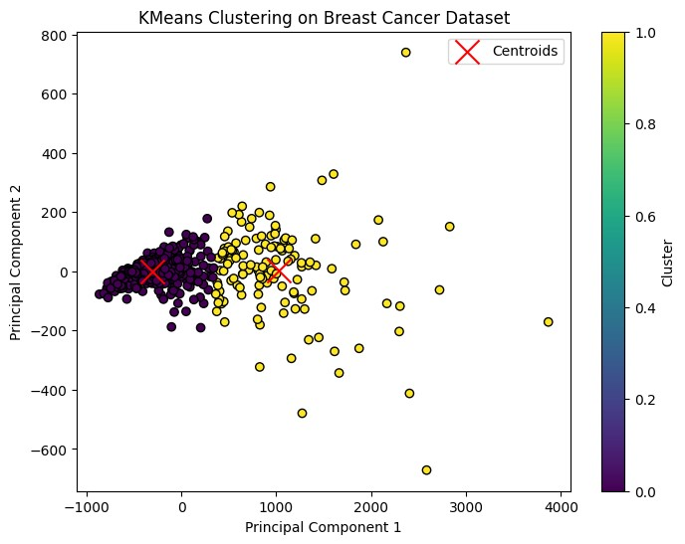

#(10) Python code on sklearn Random Forest using Iris dataset with plot

import numpy as np

import matplotlib.pyplot as plt

from sklearn.datasets import load_iris

from sklearn.ensemble import RandomForestClassifier

iris = load_iris()

X = iris.data[:, :2]

y = iris.target

clf = RandomForestClassifier(n_estimators=100, random_state=42)

clf.fit(X, y)

x_min, x_max = X[:, 0].min() - 1, X[:, 0].max() + 1

y_min, y_max = X[:, 1].min() - 1, X[:, 1].max() + 1

xx, yy = np.meshgrid(np.arange(x_min, x_max, 0.1), np.arange(y_min, y_max, 0.1))

Z = clf.predict(np.c_[xx.ravel(), yy.ravel()])

Z = Z.reshape(xx.shape)

plt.contourf(xx, yy, Z, alpha=0.8)

plt.scatter(X[:, 0], X[:, 1], c=y, edgecolors='k', s=20)

plt.xlabel('Sepal length')

plt.ylabel('Sepal width')

plt.title('Random Forest Decision Boundaries on Iris Dataset')

plt.show()

##5. Python code on sklearn logistic regression using breast_cancer with plot

import numpy as np

import matplotlib.pyplot as plt

from sklearn import datasets

from sklearn.linear_model import LogisticRegression

breast_cancer = datasets.load_breast_cancer()

X = breast_cancer.data

y = breast_cancer.target

logreg = LogisticRegression()

logreg.fit(X, y)

plt.scatter(X[:, 0], X[:, 1], c=y, cmap=plt.cm.Set1, edgecolor='k')

plt.xlabel('Feature 1')

plt.ylabel('Feature 2')

plt.show()

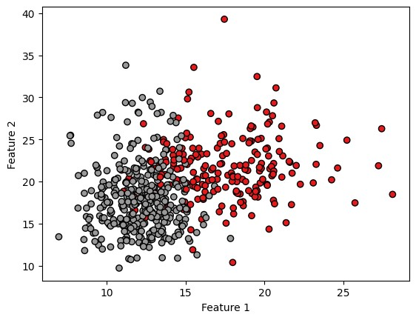

##4. Python code on sklearn logistic regression using diabetes with plot

import numpy as np

import matplotlib.pyplot as plt

from sklearn import datasets

from sklearn.linear_model import LogisticRegression

diabetes = datasets.load_diabetes()

X = diabetes.data

y = diabetes.target

logreg = LogisticRegression()

logreg.fit(X, y)

plt.scatter(X[:, 0], X[:, 1], c=y, cmap=plt.cm.Set1, edgecolor='k')

plt.xlabel('Feature 1')

plt.ylabel('Feature 2')

plt.show()

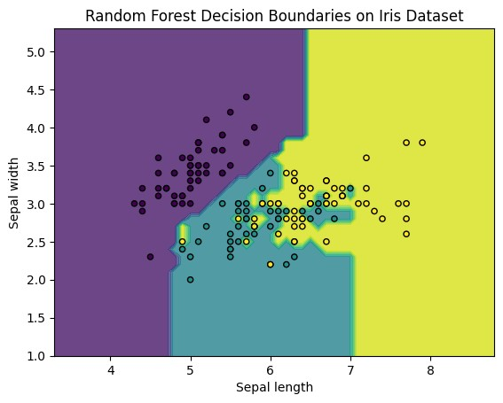

##4. Python code on sklearn logistic regression using diabetes with plot

import numpy as np

import matplotlib.pyplot as plt

from sklearn import datasets

from sklearn.linear_model import LogisticRegression

diabetes = datasets.load_diabetes()

X = diabetes.data

y = diabetes.target

logreg = LogisticRegression()

logreg.fit(X, y)

plt.scatter(X[:, 0], X[:, 1], c=y, cmap=plt.cm.Set1, edgecolor='k')

plt.xlabel('Feature 1')

plt.ylabel('Feature 2')

plt.show()

